Matt Matuk

CSIT – 210

5 December 2014

Lab 10b

**Programming Project PP 10.2**

-----**SPEC**-----

Design and implement a program that creates an exception class called StringTooLongException, designed to be thrown when a string is discovered that has too many characters in it. In the main driver of the [program, read strings from the user until the user enters “DONE”. If a string that has too many characters (say 20) is entered, throw the exception. All the thrown exception to terminate the program.

**SCRUM**

* Class StringTooLongException extends Exception
  + Method constructor()
* Class EnterStrings
  + Method main() throws StringTooLongException

**Class: StringTooLongException (Extends Exception)**

1. This class will contain a new exception
2. The class is used when a string has too many character and that class throws this exception.

**Import**

**Process**

* Variables
  + none
* Method constructor(String message)
  + Super(message)

**Class: EnterStrings (Extends Exception)**

1. This class is the main diver
2. The class will create the StringTooLongException object and send that object a message to be printed when the exception is throw
3. The class will ask the user to enter strings until “DONE” is entered
4. Terminate the program when the user enters a string longer than 20 characters and throw the exception.

**Import**

* Scanner

**Process**

* Method main() throws StringTooLongException
  + Variable
    - String[] str = new String array size 500
    - Int strCount = 0
    - Int MAX = 20
  + Create a new StringTooLongException named tooLong
  + Print a intro statement
  + Loop until the user enters done
    - Print “Enter a String: ”
    - Add the string enrterd by the user into the string array
    - If the string entered has more than MAX characters, throw tooLong exception
    - Else
      * increase strCount by one
  + If user entered “done”
    - Print all the strings entered in the str array
      * Make sure this is nicely formatted on the screen
    - Then print some ending statements

**CODE**

//************************************************************************

// EnterStrings.java Matt Matuk

// CSIT 210 Project 10.2 pg 462

// 1. This class is the main diver

// 2. The class will create the StringTooLongException object and

// send that object a message to be printed when the exception is throw

// 3. The class will ask the user to enter strings until “DONE” is

// entered

// 4. Terminate the program when the user enters a string longer

// than 20 characters and throw the exception.

//*************************************************************************

**import** java.util.Scanner;

**public** **class** EnterStrings

{

**public** **static** **void** main(String[] args) **throws** StringTooLongException

{

String[] str = **new** String[500]; // hold all strings entered

**int** strCount = 0;

**final** **int** MAX = 20; // Max length of string that can be entered

Scanner scan = **new** Scanner(System.***in***);

// creates a new exception with a message

StringTooLongException tooLong = **new** StringTooLongException("The "

+"String entered is too long.");

// intro statments

System.***out***.println("Welcome to my application. Today I will be "

+"asking you to enter strings less \nthan 20 characters in "

+"length. To stop entering strings, enter: \"DONE\"\n");

// loops untill the user entered done

**do**

{

// asks user for string then adds the string into the array

System.***out***.print("Please enter a String: ");

str[strCount] = scan.nextLine();

// throw exception if string is too long

**if** (str[strCount].length() > 20)

{

**throw** tooLong;

}

// increase string index count if string is allowed

//*****************may never reach this point*************

**else**

{

strCount++;

}

}**while** (!(str[strCount-1].equalsIgnoreCase("done")));

// prints the ending statements and all the strings entered.

//*********** may never reach this point******************

System.***out***.println();

System.***out***.println("Here are all the Strings that you entered:\n"

+"******************************************************");

**for** (**int** count = 0; count < strCount-1; count++)

{

System.***out***.println("String "+ (count+1) + ": \"" + str[count] + "\"");

}

System.***out***.println();

System.***out***.println("Thank you for using my application today.");

}

}

//************************************************************************

// StringTooLongException.java Matt Matuk

// CSIT 210 Project 10.2 pg 462

// 1. This class will contain a new exception

// 2. The class is used when a string has too many character and

// that class throws this exception.

//*************************************************************************

**public** **class** StringTooLongException **extends** Exception

{

**public** StringTooLongException(String message)

{

**super**(message);

}

}

**OUTPUT SCREEN**

**No Exception Thrown**

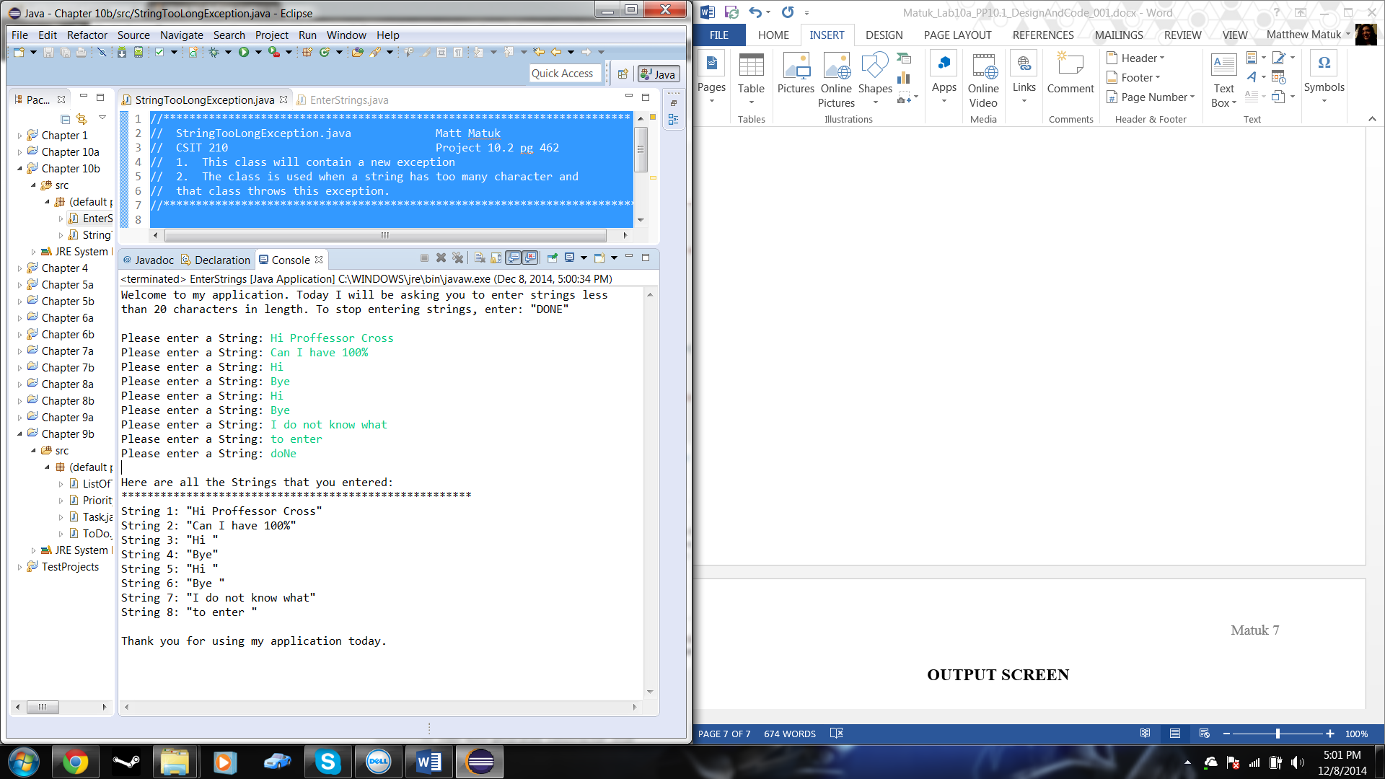

**Exception Thrown**

